1.wireless power switch, socket, remote control switch, receiver module,
2. access control, electric cars, motorcycles, automobile anti-theft products, remote door openers, closers control system
3. security, surveillance systems, home security products, electric doors, alarm host, alarm
4. rooms controls, shutter doors, windows, remote control socket, remote control LED, remote audio remote control electric doors, garage door remote control, remote control retractable doors, remote rolling gates, sliding door
5. smart home products, remote control curtains, remote MP3, audio
Product Description
[transmitter module ] Model: TX118SA-4
- Model: TX118SA-4
- Transmitting power: 11dbm
- Distance: 200M
- Emission current: 10MA
- Standby current: less than 3UA
- Rate of fire: maximum 10KB / S
- Transmit deviation: +/- 7. 5KHZ / narrow-band emission
- Modulation: ASK
- Operating Voltage: DC 3V-24V
- Encoding : EV1527 1527 Learning code
- Customizable special code: MCU type.Optional fixed encoding type: PT2262 / EV1527 / HT6P20B (Minimum order:500pcs)
- Key data: A, B, C, D groups of 4 inputs can be combined into 15 groups.Standby current: <3UA
- Each module has a unique ID address code.
- All modules K1-K4 four key code is the same.
Pins Instruction
- - : Negative power supply
- +: Positive power supply, DC 3-24V
- K1: External input keys, short to ground start transmitting data to 1, the A button on the remote control.
- K2: External input keys, short to ground 2 start transmitting data, the equivalent of the remote control B button.
- K3: External input keys, short to ground start transmitting data 3, the equivalent of the C key on the remote control.
- K4: External input keys, short to ground 4 start transmitting data, the equivalent of the remote control D keys.
- ANT: transmitting antenna
- A typical application circuit is shown below
​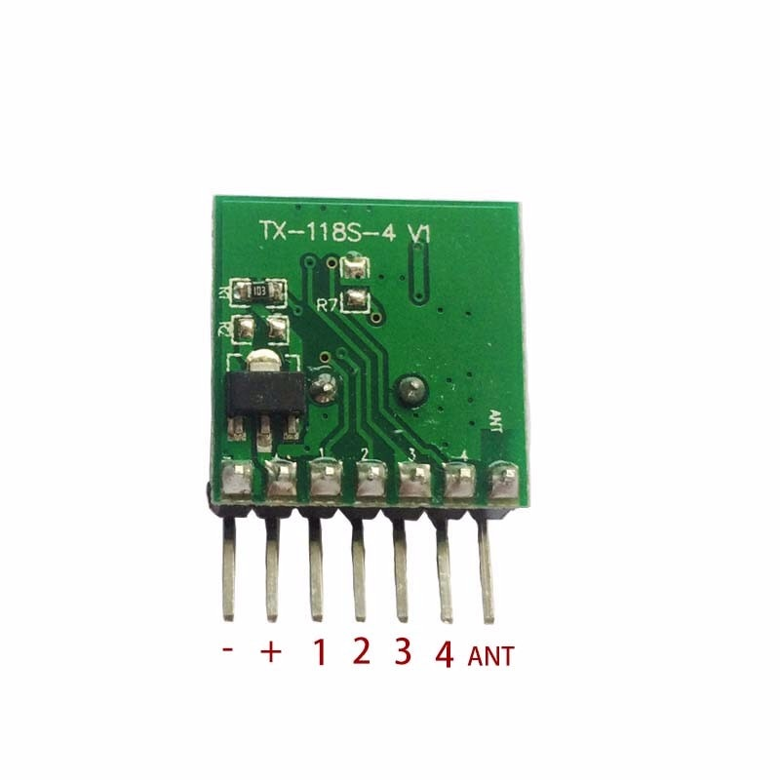
​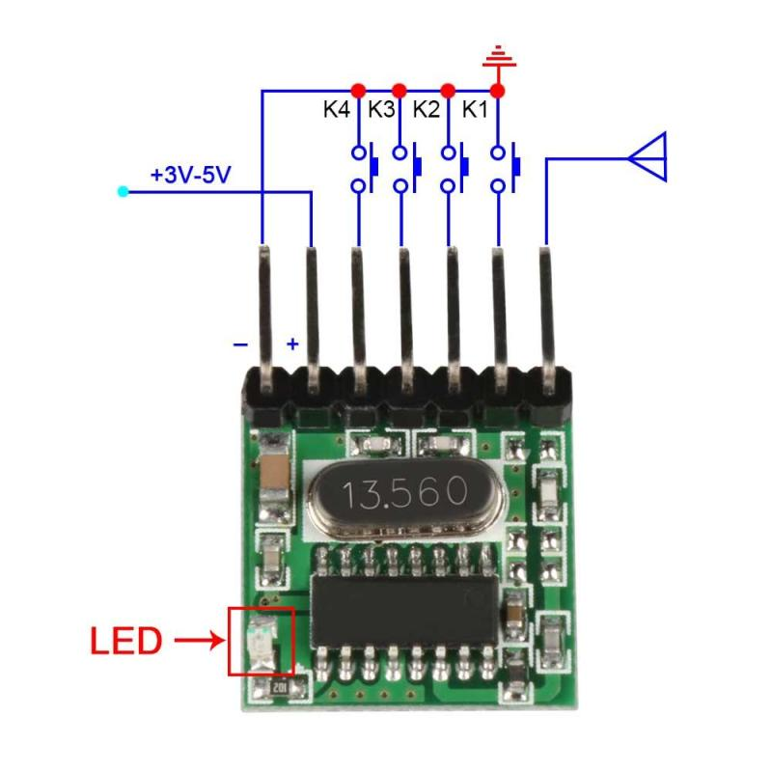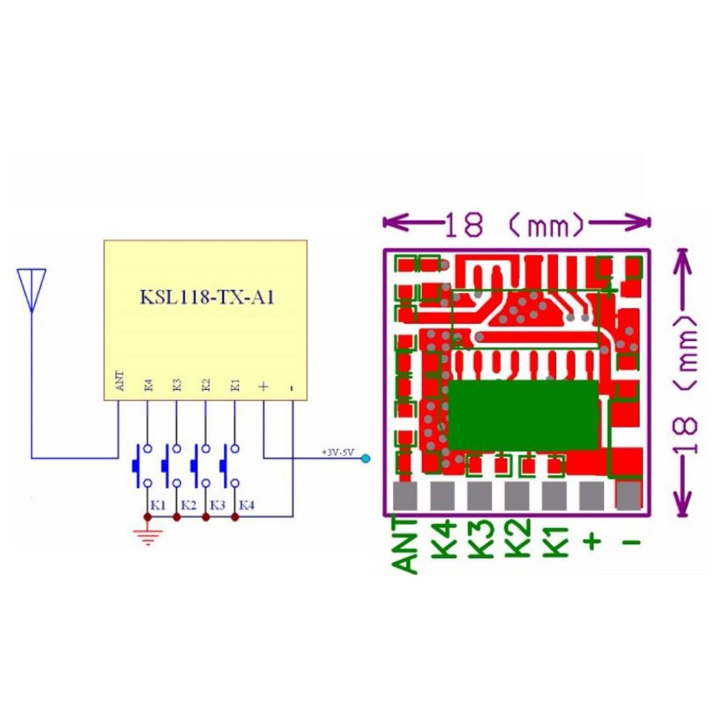
[Receiver module ] Product Model: RX480-E4
- Working Voltage : DC3.3~5V
- Quiescent Current : ≤5mA
- Output current : 10 mA
- Working Frequency: 433MHz
- Receive Sensitivity: -108dB
- Receive Distance: 15 meters above
- Frequency band: ±0.2MHz
- Working Temperature : -25~75
- Working mode: Momentary Mode , self-locking (Toggle-Mode of the 4 Channels) , interlocking
- The output: 4 channel CMOS level signal Corresponding to the remote control ABCD 4 buttons.

note:
Compatible transmitter encoding type: EV1527
If your transmitters are not using the encoding EV1527,
they will not be connection to the receiver.
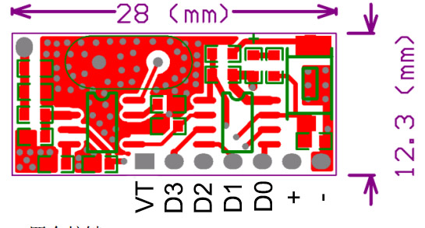
Pins Instruction

GND : ground or negative pole
+V : DC3.3~5V input
D0: Data output
D1: Data output
D2: Data output
D3: Data output
VT: Output
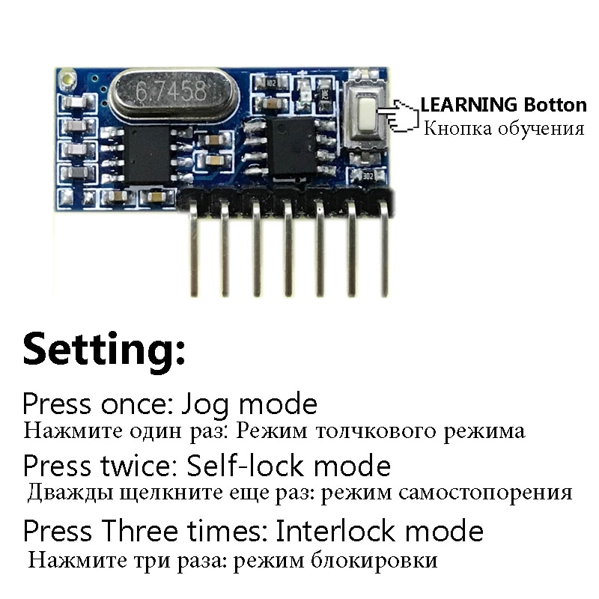
Instructions

How To Programming:​

1. Delete existing data: Press learning button 8 times (on the receiver）. Response: LED flashes 7 times.
2. Learning remote code: press learning key (on the receiver） once, twice or three times (see below).
LED turns on: learning mode is active. Press any button of the remote control.
LED indicator flashes three times: learning successfully completed.
3. Test: after the above operation , the receiver board can be controlled by the remote control .

More transmitters with different IDs can be learned and stored additionally, starting with step 2.
A mixture of different modes is possible.

Button usage (sets mode and starts pairing process):
Press once (on the receiver） : Inching mode (Momentary Mode)
Press twice (on the receiver） : self-Lock Mode (Toggle-Mode of the 4 Channels)
Press three times (on the receiver） : interlocked mode (selected channel active and be cleared, if another channel becomes active)

(This instructions is provided by Manfred, thanks to Manfred)
