# 5V WiFi Relay Module

**LC-WM-Relay-8266-5V**

**ESP8266 5V WiFi Relay IoT Smart Home Mobile APP Remote Control Switch**

**I. Overview**
The 5V WiFi relay module is equipped with an ESP8266 WiFi module and microcontroller. It can receive serial port commands from a mobile APP to achieve wireless control of the relay within the local area network.

**II. Features**
1. Onboard ESP8266 WiFi module supports up to 5 clients in AP mode.
2. Two working modes:
(1) Mobile phone directly connects to the WiFi module;
(2) Both mobile phone and WiFi module connect to the same router.
3. Transmission distance:
(1) In an open environment, the maximum transmission distance is 400m when the phone connects directly to the WiFi module;
(2) When both the WiFi module and phone connect to a router, the transmission distance depends on the router's signal strength;
(3) Onboard 5V, 10A/250V AC, 10A/30V DC relay, capable of 100,000 continuous operations, with diode freewheeling protection and short response time.

**III. Hardware Introduction and Description**
Board dimensions: 45×28mm

Board function description:
IN+, IN-: 5V power input;
TX, RX, GND: Serial debugging pins;

Usage instructions:
1. The onboard ESP8266 WiFi module has three working modes: STA (client), AP (hotspot), STA+AP (client + hotspot). Choose the appropriate mode based on the module's working method.
2. The module must be configured using AT commands sent via a USB-to-TTL module and serial debugging software on a computer. Connect the RX, TX, GND pins of the USB-to-TTL module to the TX, RX, GND pins of the module, and connect IN+, IN- to a 5V power supply.
3. The default baud rate of the WiFi module is usually 115200 or 9600 and can be modified with AT commands, e.g., `AT+CIOBAUD=115200`. It is generally recommended to use 115200. The program uses 115200, so ensure the ESP8266 baud rate matches.

**Working Mode 1 (Phone directly connects to the WiFi module):**
Open serial debugging software on the computer and send the following AT commands in order to configure the WiFi module:
*(First power-on defaults to this mode, IP address: 192.168.4.1, no need to send the instructions below.)*

1. `AT+CWMODE=2`, select AP mode;
2. `AT+RST`, reset;
3. `AT+CIPMUX=1`, enable multiple connections;
4. `AT+CIPSERVER=1,8080`, enable TCP server, set port number;
5. `AT+CIFSR`, check the IP address in AP mode, e.g., APIP, "192.168.4.1";

Note: Set baud rate to 115200 when sending commands, add carriage return and line feed. Return "OK" indicates success.

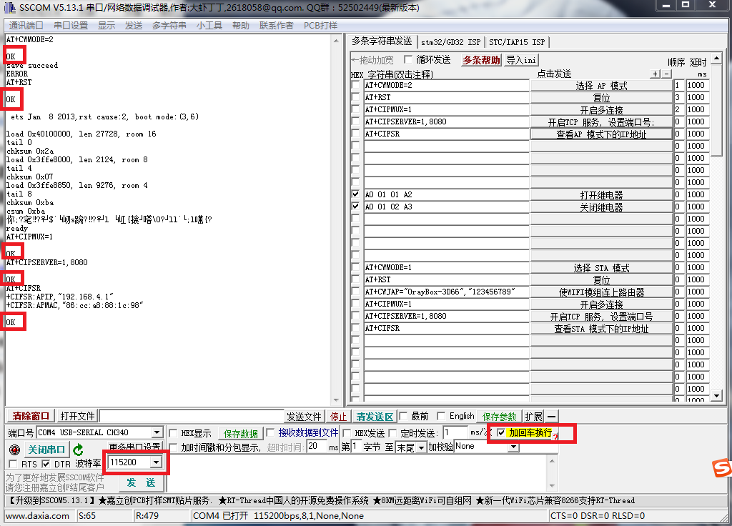

6. Connect an Android phone to the hotspot (AP) signal emitted by the WiFi module (default name: HCW or ESP_XXXXXX, can be customized).

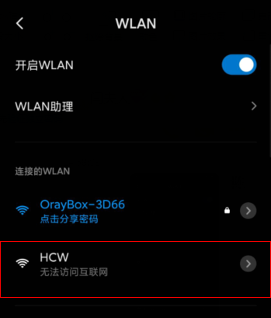


8. After successful connection, open the mobile APP: "TCP Connect".

Click Connect, enter the IP address and port number.
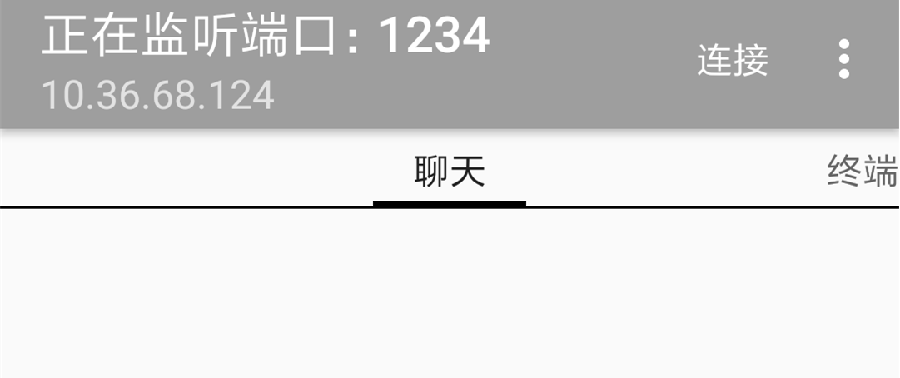
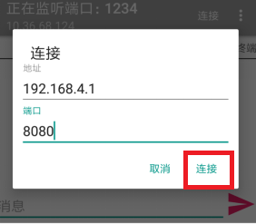

Click Connect. After successful connection, edit the button and enter the relay control commands (must select hexadecimal).
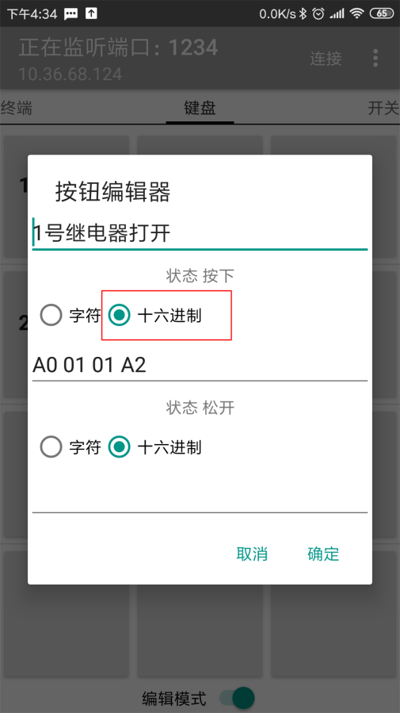

There are two switch commands, enter them for each button:
- `A0 01 01 A2` Turn relay ON
- `A0 01 02 A3` Turn relay OFF

**Working Mode 2 (Both phone and WiFi module connect to the same router):**
Open serial debugging software on the computer and send the following AT commands in order to configure the WiFi module:

1. `AT+CWMODE=1`, select STA mode;
2. `AT+RST`, reset;
3. `AT+CWJAP=<ssid>, <password>`, connect the WiFi module to the router, e.g., `AT+CWJAP="LCTECH","12345678"`;
4. `AT+CIPMUX=1`, enable multiple connections;
5. `AT+CIPSERVER=1,8080`, enable TCP server, set port number;
6. `AT+CIFSR`, check the IP address in STA mode, e.g., STAIP, "10.168.1.154";
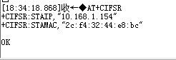

7. Connect the phone to the router.

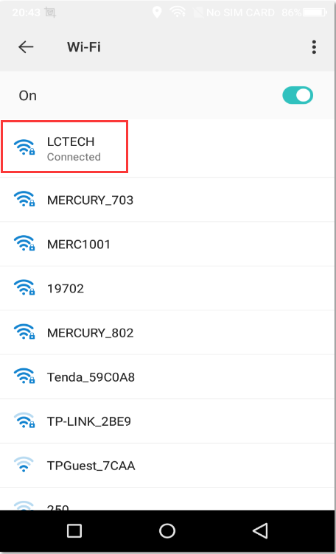

8. Open the mobile APP: "TCP Connect".

9. Click Connect.

Select Other Host.

10. Enter the IP address noted earlier.
*(Note: In Mode 2, the IP address of the WiFi relay module is assigned by the local router and may change after each connection.)*
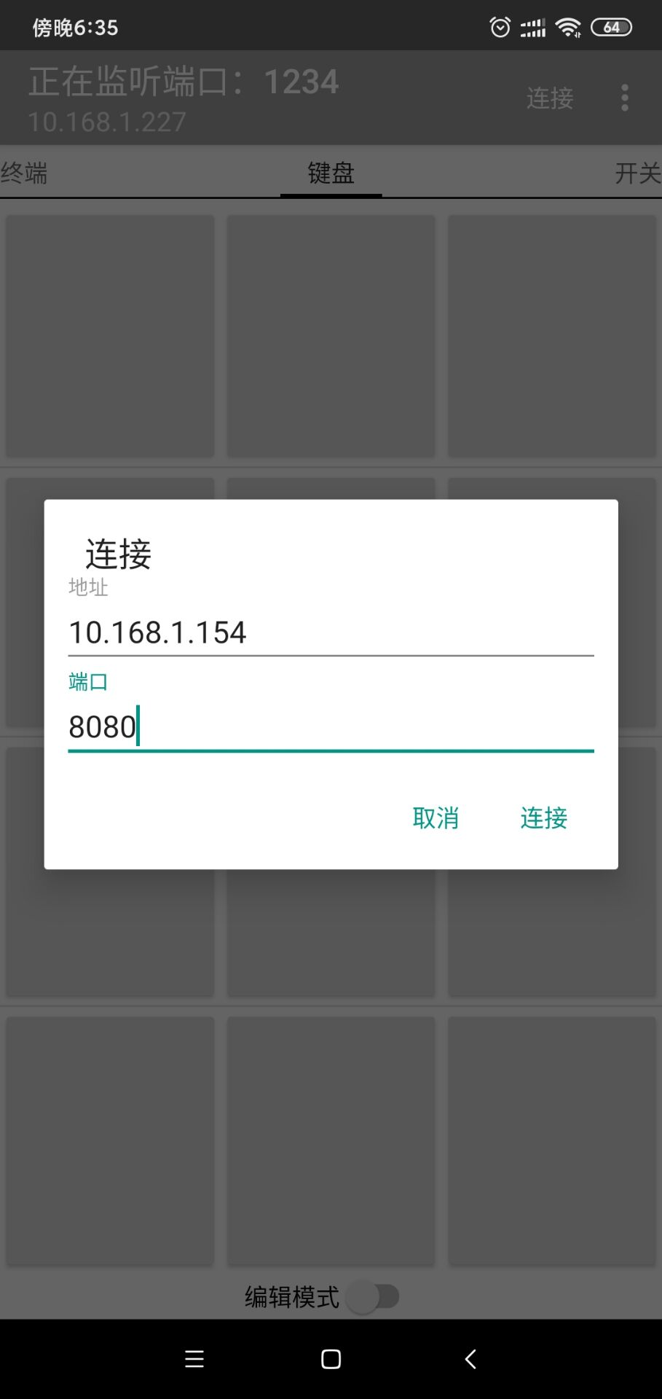

11. The APP will show a success message at the bottom when connected. Click the button to control the relay normally.

If configuration fails, check whether the ESP8266 is properly connected to the module pin header, ensure jumper cap contact is good, and verify the baud rate is the default 115200. Poor network conditions may affect functionality, such as unresponsive commands.

**Tips:**
1. **Mode Saving:** Modes can be saved: `AT+CWMODE=1` / `AT+CWMODE=2`.
"save succeed" must appear after setting to confirm success. No need to set again on next power-on. In `AT+CWMODE=1` mode, router credentials are saved automatically; "save succeed" may not appear.
Note: "error" may appear after "save succeed" because ESP8266 does not recognize "save succeed". This does not affect functionality.
No need to send serial data on each power-up, but the mobile APP needs to reconnect.

Other default settings on power-up (can be modified):
- `AT+CIPMUX=1`, enable multiple connections;
- `AT+CIPSERVER=1,8080`, enable TCP server, set port number;

2. **ESP8266 Timeout Mechanism:** The module disconnects the phone if no command is received within a certain time (default 180s). Use `AT+CIPSTO=<time>` to change this (time range 0-7200), e.g., `AT+CIPSTO=3600`.

3. If AT commands get no response, check if the serial debugging software baud rate is correct (usually 115200). If sending an AT command returns the same text without "OK", try enabling "Send New Line" or pressing "ENTER" after typing the command before clicking "Send".

4. To control the relay directly via serial debugging software on the computer, connect the RX, TX, GND pins of a USB-to-TTL module to the RX, TX, GND pins of the module, and connect IN+, IN- to 5V power. Send in hexadecimal format (hex):
- `A00101A2` to turn relay ON
- `A00102A3` to turn relay OFF.

