PRODUCT DATASHEET GSP9-C40PV 600V DC 1000V DC Surge protective device
Application
This DC surge protective device is applied low voltage standard IEC/EN 61643-11 to protect against DC power line system and other equipment from over voltage and instantaneous over voltage damage. Widely used in photovoltaic comber box, power inverter, DC distribution cabinet etc. It has advantages of large discharge current, fast respond time, low residual voltage. Max. PV voltage up to UCPV ≤1000V dc.

Main features
1. High discharge capacity, quick response, plugged module.
2. Fast response time, din rail installation.
3. Double thermal disconnection devices, provide more reliable protection.
4. Green window means normal, red means defect, need to change module.
5. Remote signaling contact optional.
6. T1+T2 surge protection.

Technical parameter
Model | GSP9-C40PV
Test standard | IEC/EN 61643-11;GB18802.11
SPD type | T1+T2/Class I+ II
Max. PV voltage [ Uc pv ] | 600V DC | 1000V DC
Nominal discharge current (8/20µs) | 20kA
Maximum discharge current(8/20µs) | 40kA
Iimp current (10/350µs) | 6.25kA
Poles | 2P | 2P/3P
Voltage protection level Up pv | 2.6kV | 3.6kV
Response time Ta | 25ns
Connection wire specification | 4mm2(L/N); 6mm2(PE)
Mounting | 35mm Din Rail
Matched fuse or circuit breaker | 32A
Type of remote signaling contact  (Optional) | C+NC: Normally closed
Type of remote signaling contact  (Optional) | C+NO: Normally open
Type of remote signaling contact  (Optional) | C: Common contact
Max. Voltage/Current for remote signaling | 1A/2A/3A 125V AC
Wiring for remote signaling | 1.5mm2 max.
Operating temperature | -40°C to +80°C
Shell material | UL94-V0 fireproof material

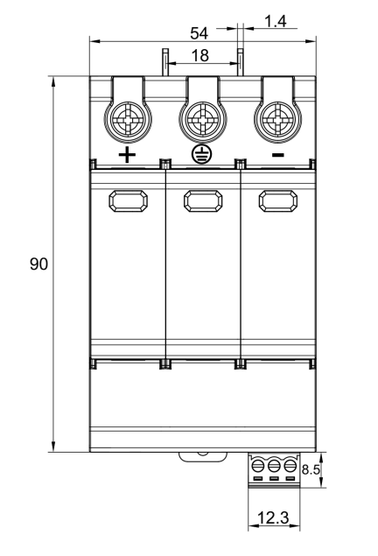
Dimension details (unit: mm)
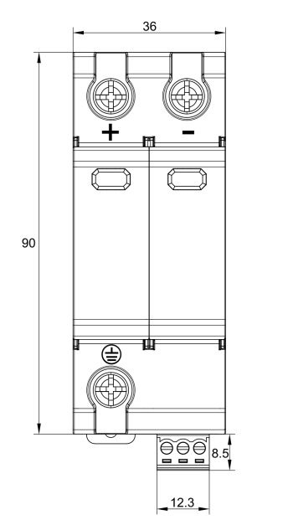
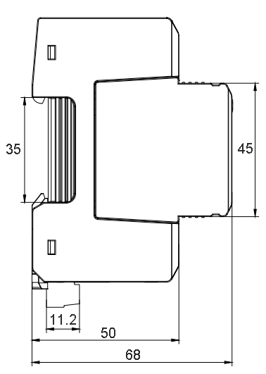
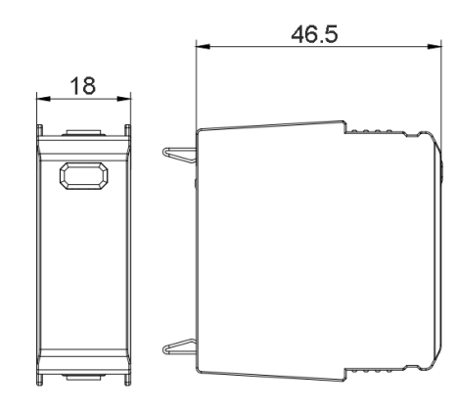

Installation Diagram(2P&3P)
